**[ST10443658]**

**[MULWELI MBEDZI]**

[WEDE5020 POE PART1&2]



TABLE OF CONTENT

TABLE OF CONTENT 2

WEBSITE CHOICE 3

WEBSITE ASSETS 4

WEBSITE PAGES AND CONTENT 8

PART 2 11

LIST OF REFERENCES 12

***WEBSITE CHOICE***

**VEREENIGING ARTS SOCIETY**

**F**or this project, I have chosen to create a website for a fictional local non-profit organization called “***VEREENIGING ARTS SOCIETY*** " (VAS). ***VEREENIGING ARTS SOCIETY*** is dedicated to fostering creativity and cultural expression within South African communities by providing accessible art education, workshops, and exhibitions. The organization aims to support emerging artists, encourage cultural exchange, and enhance the community's appreciation for the arts, reflecting the rich and diverse cultural heritage of South Africa.

The idea for ***VEREENIGING ARTS SOCIETY*** arises from the recognition of the arts' vital role in promoting social cohesion, celebrating diversity, and addressing social issues. In many South African communities, access to arts education and opportunities for creative expression is limited due to economic and geographic barriers. ***VEREENIGING ARTS SOCIETY*** seeks to address these challenges by offering a variety of programs and events that cater to people of all ages and backgrounds, ensuring that everyone has the opportunity to engage with the arts.

A key feature of the ***VEREENIGING ARTS SOCIETY*** website will be its events calendar, which showcases upcoming workshops, exhibitions, and performances across different provinces. This feature will help users stay informed about local arts events and encourage participation from various communities. Additionally, the website will provide resources such as online tutorials, artist profiles, and a gallery of works created by community members, serving as inspiration and guidance for aspiring artists.

To promote collaboration and cultural exchange, the ***VEREENIGING ARTS SOCIETY*** website will include a forum where artists and art enthusiasts can connect, share ideas, and collaborate on projects. This platform will foster a sense of community and encourage individuals to explore new artistic perspectives. The website will also feature a section dedicated to highlighting the work of South African artists, providing them with a platform to showcase their talent and gain recognition.

In terms of design, the ***VEREENIGING ARTS SOCIETY*** website will be visually engaging, reflecting the vibrant and dynamic nature of South African arts and culture. The site will be easy to navigate, with intuitive menus and search functionality to help users find information quickly. By creating an online space that celebrates and supports the arts, ***VEREENIGING ARTS SOCIETY*** aims to empower individuals, strengthen community ties, and enrich the cultural landscape of South Africa.

***WEBSITE ASSETS***

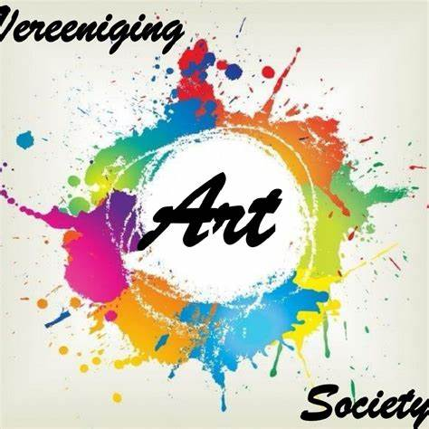 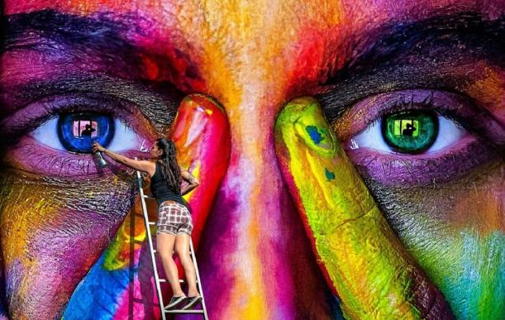

FIGURE 1.1: Facebook.2024 FIGURE 1.2: Carole A.Feuerman.2024

THIS IS THE FIRST DESIGN THAT WAS DESIGNED BY: NKU

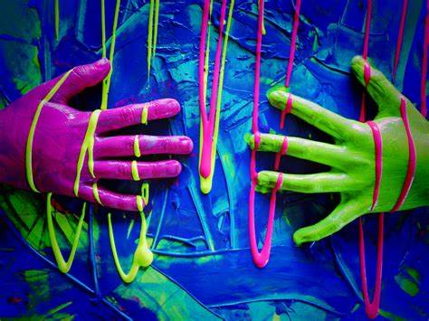 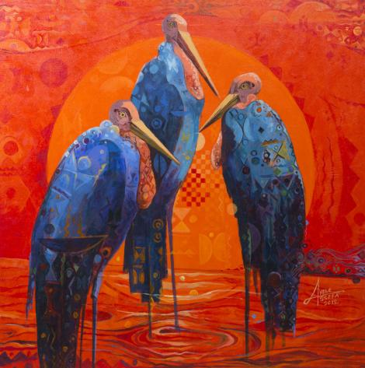

FIGURE 1.3: Facebook. 2024 FIGURE 1.4: St George Art Gallery.2012

THIS IS THE SECOND DESIGN, WHICH WAS DESIGNED THIS IS THE THIRD DESIGN DESIGNED

BY A BLIND MAN BY: AYELE  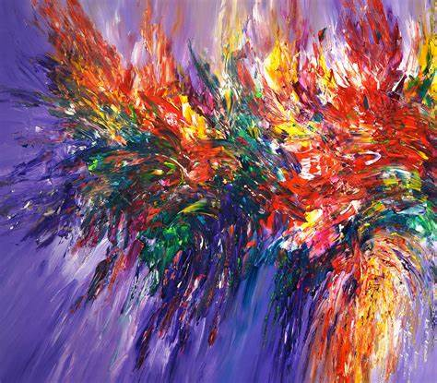

FIGURE 1.5:Big Stock Photo.2023 FIGURE 1.6:Shutterstock.2018

THIS PICTURE INDICATES SOME OF OUR RESOURCES THIS IS THE FOURTH DESIGN DESIGNED

WHICH WE USE. BY: NONO



FIGURE 1.7: Adobe Stock.2022

THIS IS A DESIGN WHICH WAS DESIGNED BY:JANE



FIGURE 1.8:Shutterstock.2024

LASTLY THIS IS OUR FAMOUS PICTURE WHICH MADE US TO

BE VIRAL, AS IT WAS DESIGNED BY A YOUNG AND TALENT

BOY, ZONKE.M. IT IS ALSO OUR BACKGROUND FOR THE

WEBSITE.

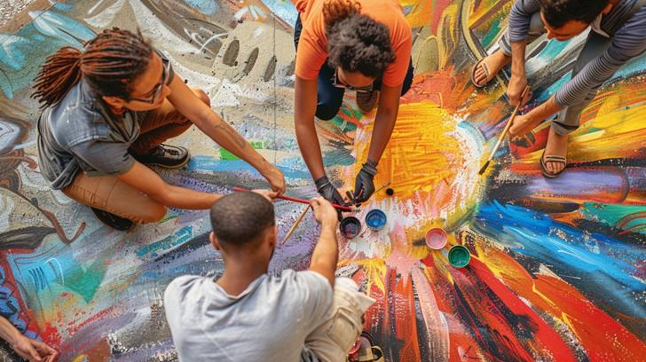

Figure: 1.9: StockCake.2020

Image of a group of artists collaborating

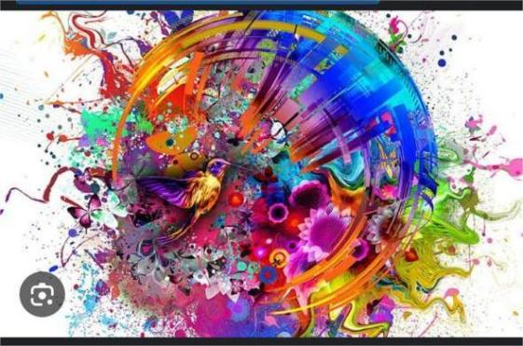 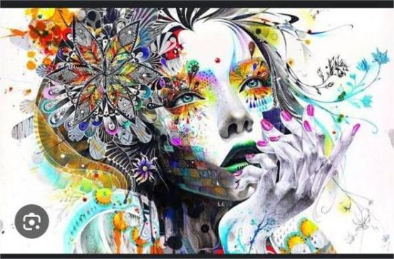

FIGURE 1.10: Peakpx.com FIGURE 1.11: WALLPAPERS.COM

THIS IS THE HD CREATIVE ART. THIS IS THE COOL ART OF A WOMEN.

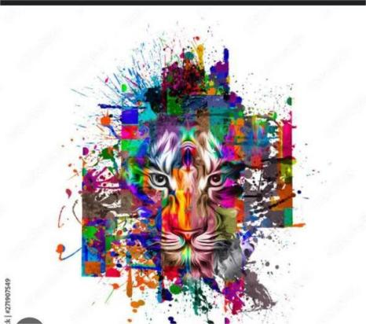 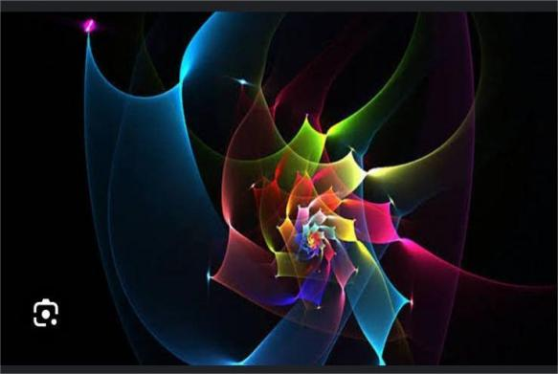

FIGURE 1.12: ADOBE STOCK.2022 FIGURE 1.13: HD WALLPAPERS.2020

THIS IS AN ANIMAL ART THIS IS A COLOURFUL CREATIVE GRAPHIC DESIGN

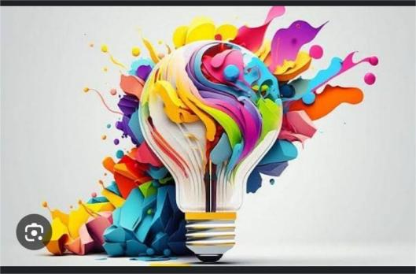 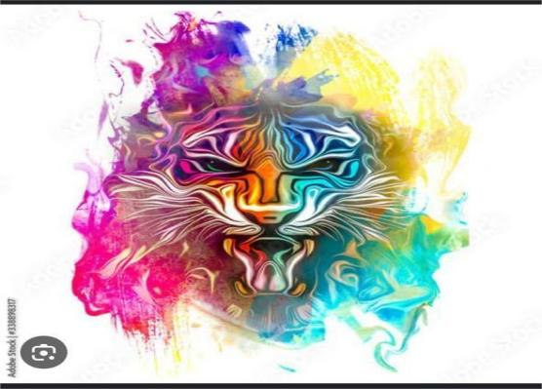

FIGURE 1.14: Medium FIGURE 1.15: ADOBE STOCK

ARTS IS WHAT YOU THINK TIGER HEAD ART

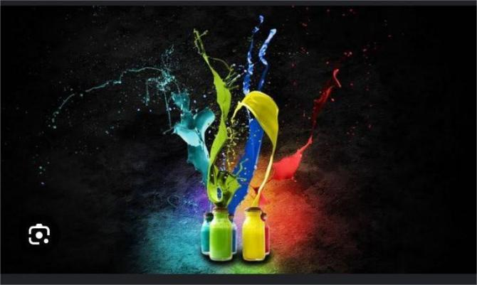 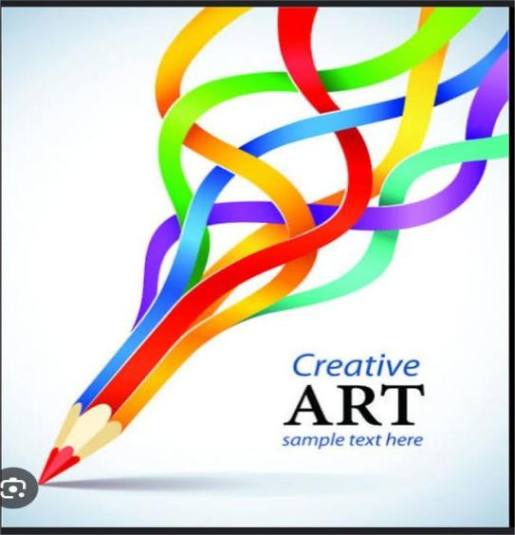

FIGURE 1.16: PINTEREST FIGURE 1.17:PINTEREST

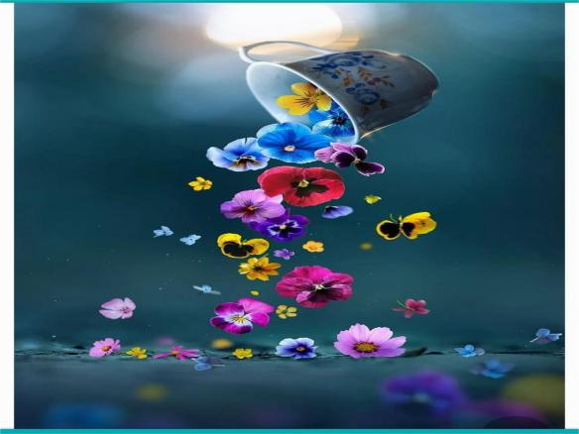 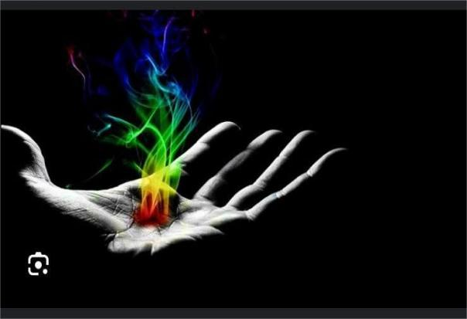

FIGURE 1.18: PEAKPX FIGURE 1.19: HD WALLPAPERS

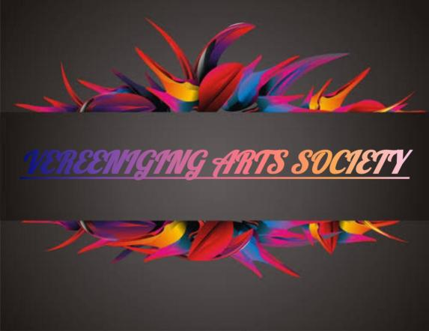 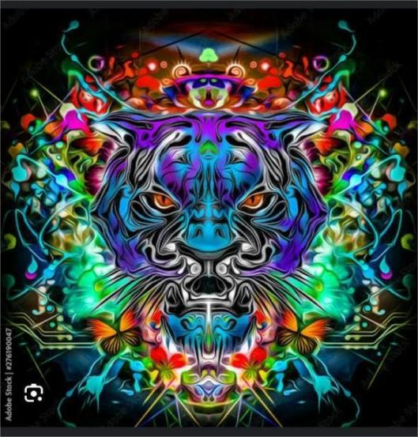

FIGURE 1.20: FACEBOOK FIGURE 1.21: ADOBE STOCK

THIS IS OUR LOGO FOR THE ORGANIZATION THIS IS THE HEAD OF THE TIGER WHICH WAS DESIGNED

***WEBSITE PAGES AND CONTENT***

* **HOME PAGE**: It is the introduction to ***VEREENIGING ARTS SOCIETY*** and a summary of what visitors can expect on the website.

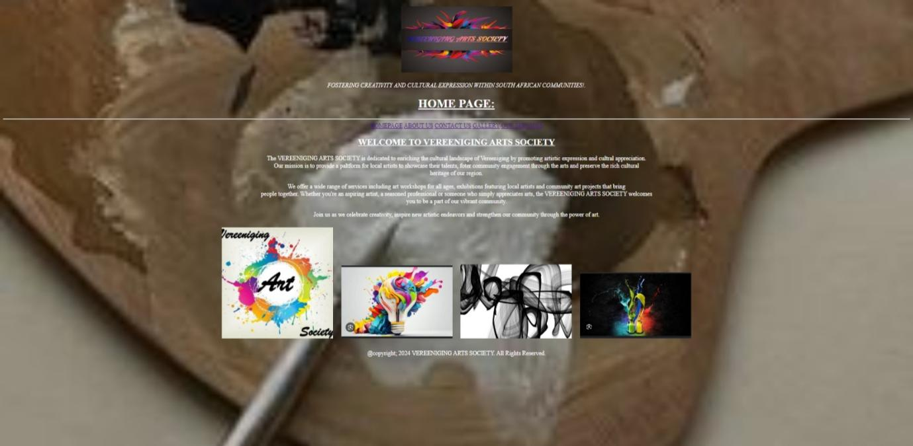

* **ABOUT US**: It is a detailed description of the organization’s goals, mission and how it supports communities. Image of a group of artists collaborating.

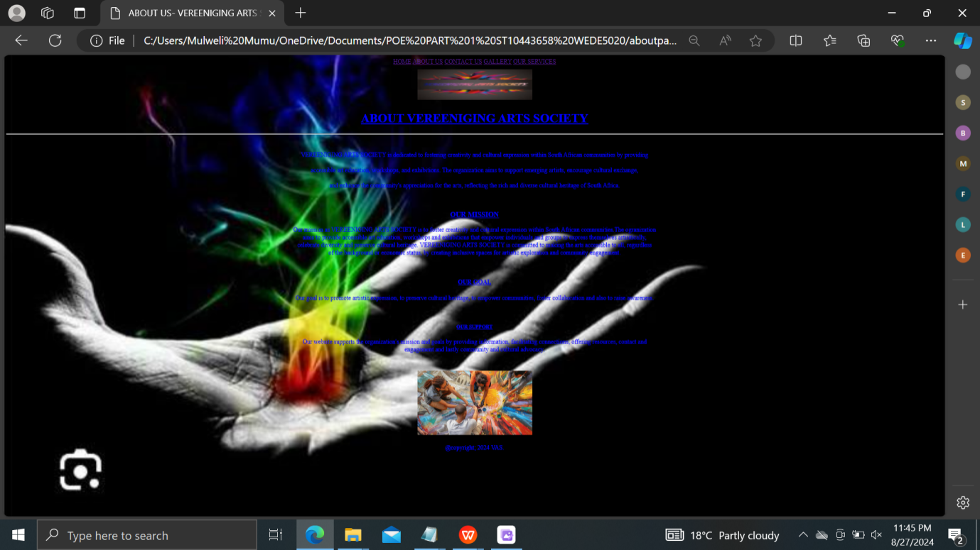

* **CONTACT US**: Contact details, including email and address for inquiries. Image representing contact information.

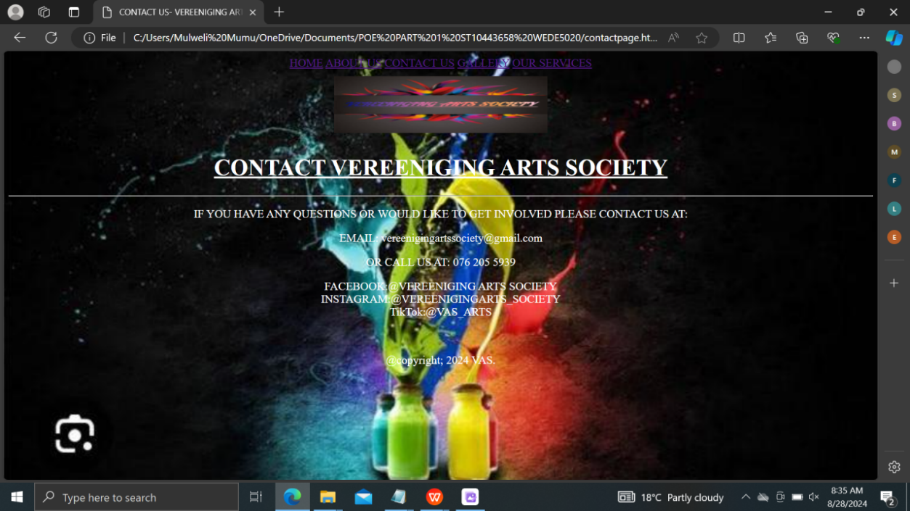

* **GALLERY**: A collection of images of various artworks created by community members. Each image with a brief description of the artwork.

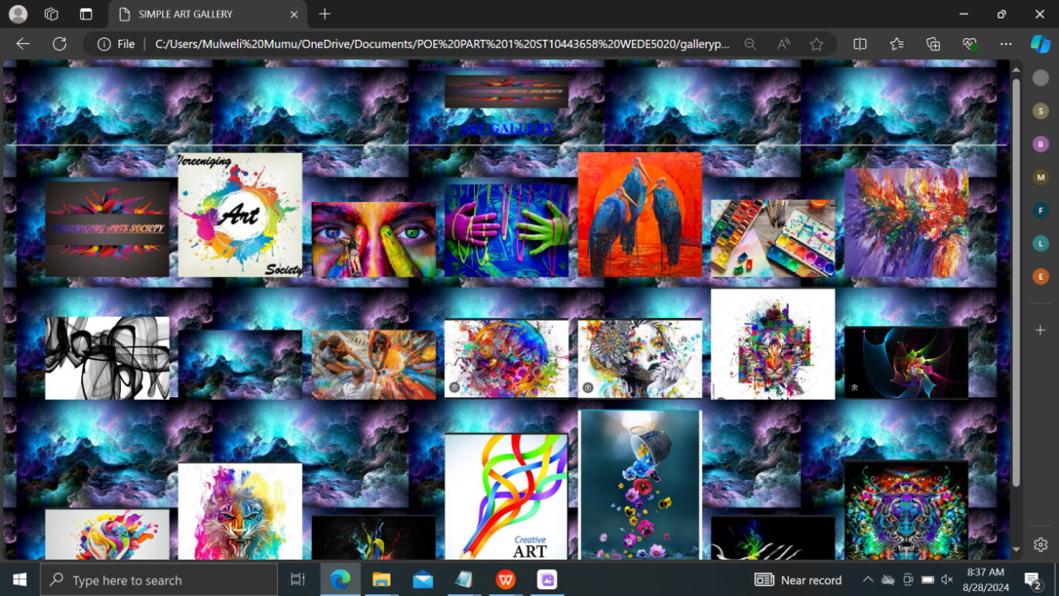

* **SERVICES**: It is all about the art workshops, the exhibition, art therapy,artist mentorship, the community projects and also how it will benefit the community.

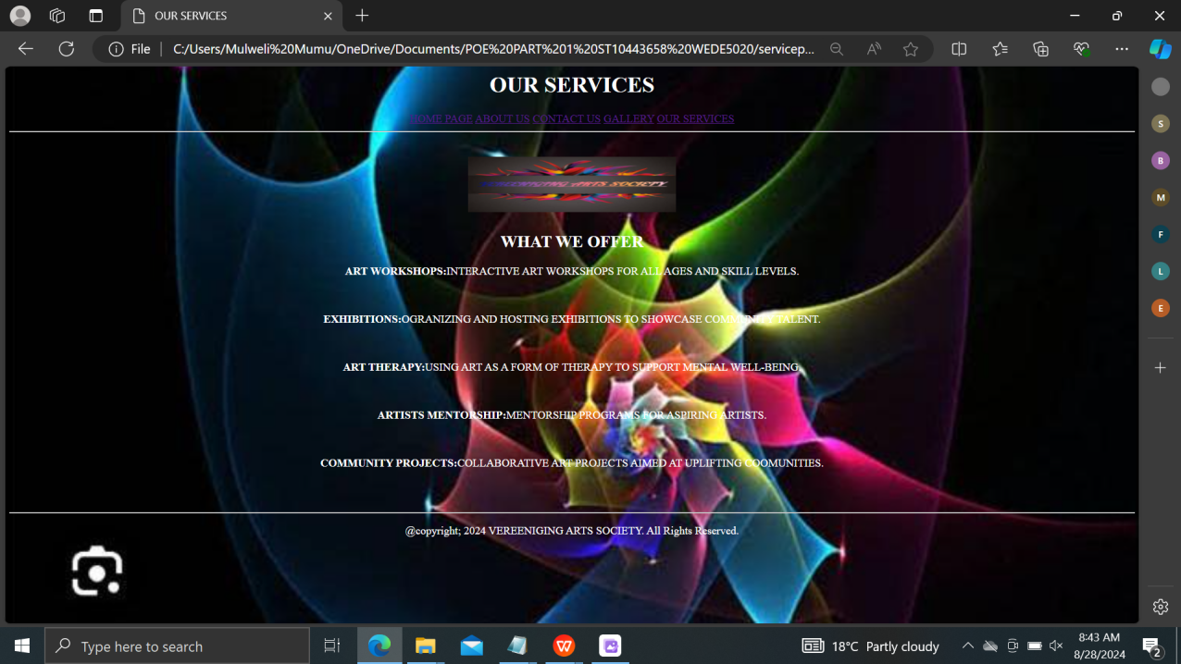

***PART 2***

1. ***IMPROVEMENT ON PART 1***

* **LAYOUT AND THE STRUCTURE**

**- I improved the overall organization of the content for the better readability.**

**- I then added the navigation menus and made them visually appealing.**

* **STYLING(CSS)**

**- I added a proper font styling and color contrast to make the content stand out.**

**- I improved the use of the background images for a cleaner and more professional look.**

**- I then added the hover effects for the links and buttons to make the site more interactive.**

**-Enhance image gallery layout.**

* **MOBILE RESPONSIVENESS**

**- I made sure that the website is responsive and it works well on different screen sizes.**

* **ACCESSIBILITY**

**- I improved the text contrast and the structure HTML headings properly for screen readers.**

***WEBSITE PAGES AND CONTENT PART 2***

***HOME PAGE IMPROVEMENTS***

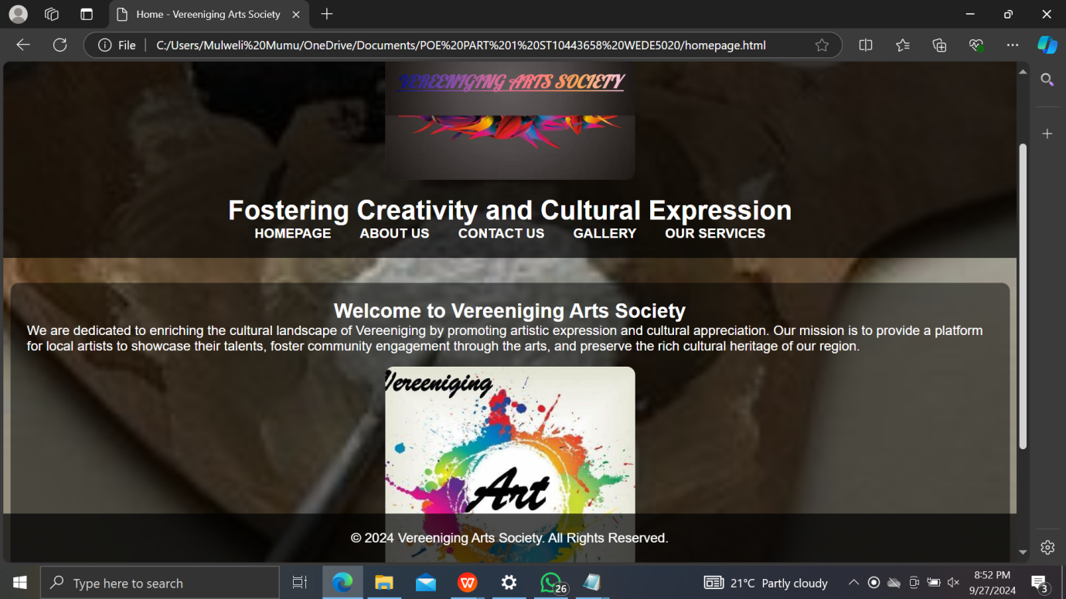

Home Page

Improvements:

• Improved header layout.

• Better image alignment and text spacing.

• Added responsive design for different screen sizes.

***ABOUT US IMPROVEMENT***

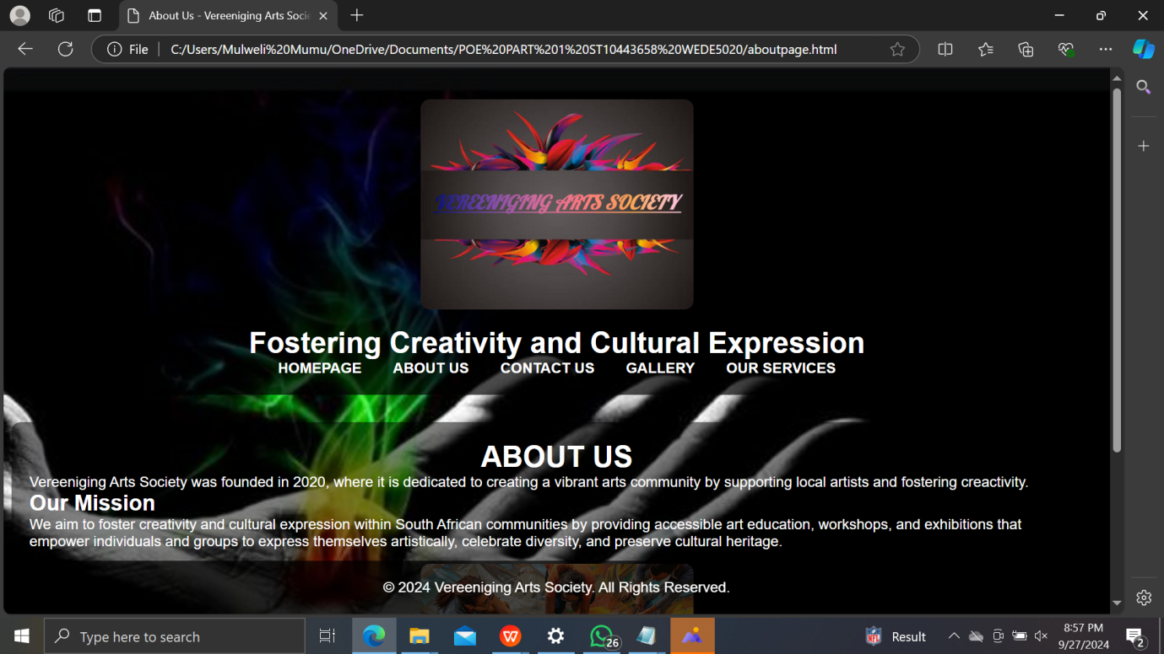

***CONTACT US PAGE IMPROVEMENT***

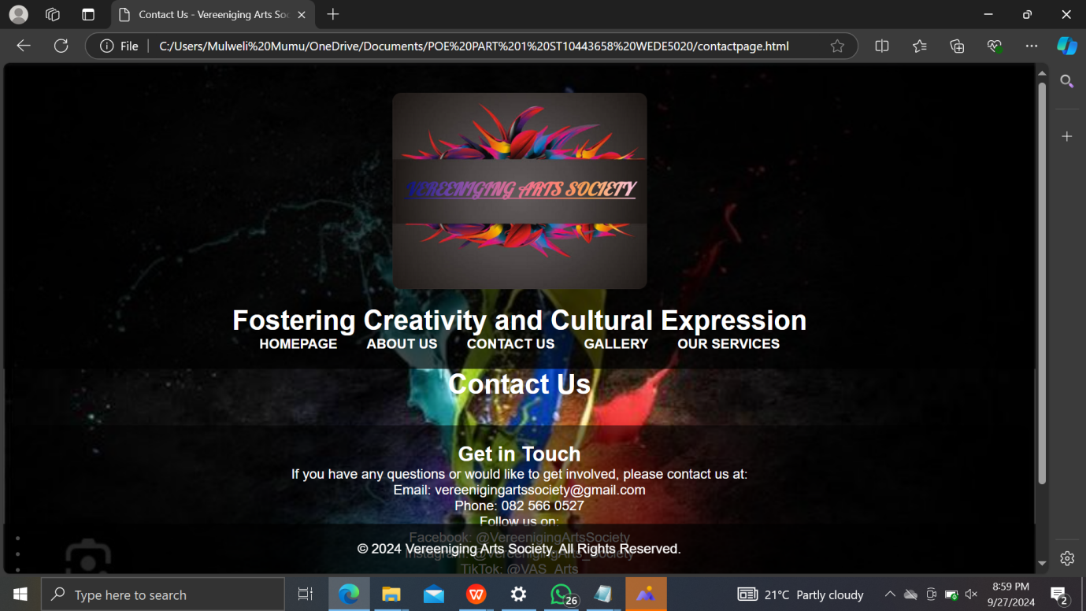

***GALLERY PAGE IMPROVEMENT***

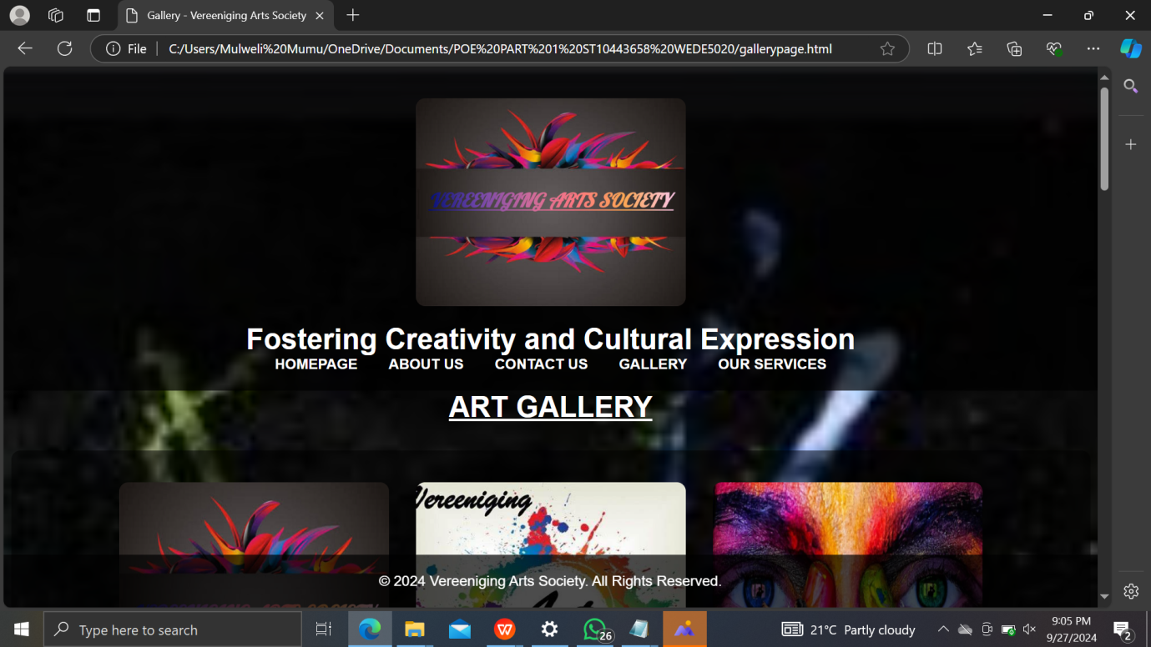

***OUR SERVICE PAGE IMPROVEMENT***

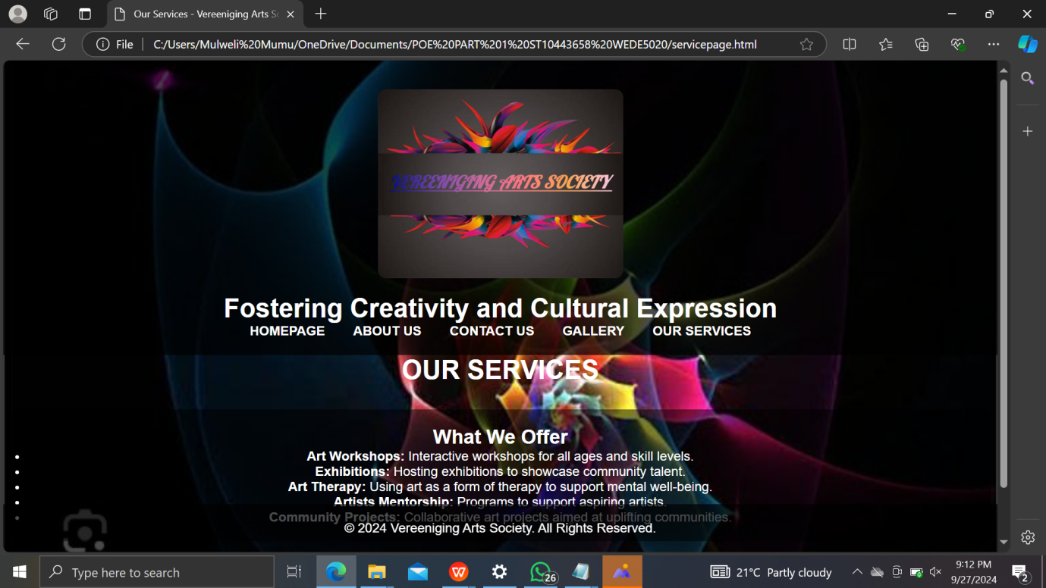

***CSS (style.css)***

**WEBSITE Improvements for part 1:**

• Added a clean and modern layout with better spacing.

• Included hover effects for links.

• Made the page responsive by adding media queries.

**Documentation on Improvements**

1. Layout Structure: The structure of the website has been improved with a navigation bar, a main content section, and a footer. This makes it easier for users to navigate and consume the content.

2. Background and Image Styling: The background image now covers the entire screen neatly, and content is layered over it with a semi-transparent background for improved readability.

3. Responsiveness: The website now adapts to different screen sizes, ensuring a good user experience on mobile devices by using media queries.

4. Improved Link Interactions: Links in the navigation bar now have hover effects, making the website more interactive and polished.

5. Typography: Consistent font sizes and spacing have been applied to improve readability, especially for large blocks of text.

**LIST OF REFERENCES**

* What is vereeniging arts society? Available at>

<https://vereenigingartsoci.wixsite.com>

* Mbedzi, M. 2024. An image of the logo of the organization[photograph] [personal collection]. Unpublished Carole, A.F(2024) the first design(see figure1.2).Facebook(2024) the second design(see figure 1.3). St George Art Gallery Ayele (2012) the third design(see figure1.4). Big Stock Photo(2023) the picture indicating some of the pictures(see figure 1.5). Shutterstock(2018) the fourth design(see figure 1.6). Adobe Stock(2022) the design which was designed by Jane(see figure 1.7). Shutterstock(2024) the famous design(figure 1.8). StockCake(2020) Image of a group of artists collaborating(figure 1.9)
* <https://images.app.goo.gl/yjVZVKvo3J8JV7gv9>
* <https://images.app.goo.gl/gNDNp3RzDLNbVETM6>
* <https://images.app.goo.gl/i6kVi8y46XcqFTHb7>
* <https://images.app.goo.gl/gy4DZsoYcJCfTdMX7>
* <https://images.app.goo.gl/FUo7bZgm6p1hvG8Z9>
* <https://images.app.goo.gl/7BmseSXU6BRiUKLg7>
* <https://images.app.goo.gl/tyVvEEKM9rmSLr7UA>
* <https://images.app.goo.gl/Jw6fmRj1uRvSzivc6>
* <https://images.app.goo.gl/5ynrZvDJ9KhHs1KN7>
* <https://images.app.goo.gl/X8vKYxkrqyqWYyNw8>